1.Registered date and First booking date diff => plot distribution histogram (filtere datediff 0-30)

example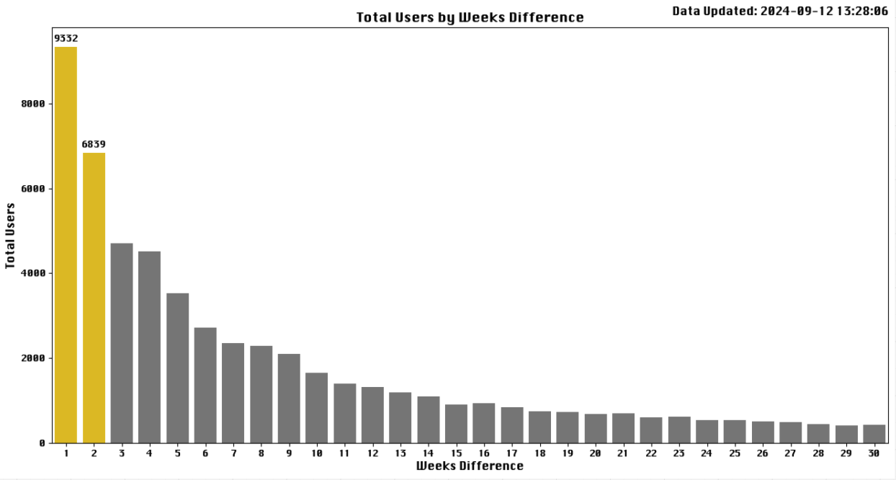

** if Registered date and First booking date is the same date, datediff must be 0

2.

User first booking interact after push message

user_segment_id = 138 : first called 29.05.2025 at 16:03, final called 01.06.2025 at 12:00

user_segment_id = 139 : first called 29.05.2025 at 16:03, final called 01.06.2025 at 12:00